**Detectron2 with mask RCNN**

Detectron2 is Facebook AI Research's next generation library that provides state-of-the-art detection and segmentation algorithms. It is the successor of Detectron and maskrcnn-benchmark. It supports a number of computer vision research projects and production applications in Facebook.

* I’ve used pre-trained as well as custom trained(balloon dataset).
* Total no. of steps = 300
* Total loss = 0.3452
* AP= 73.119

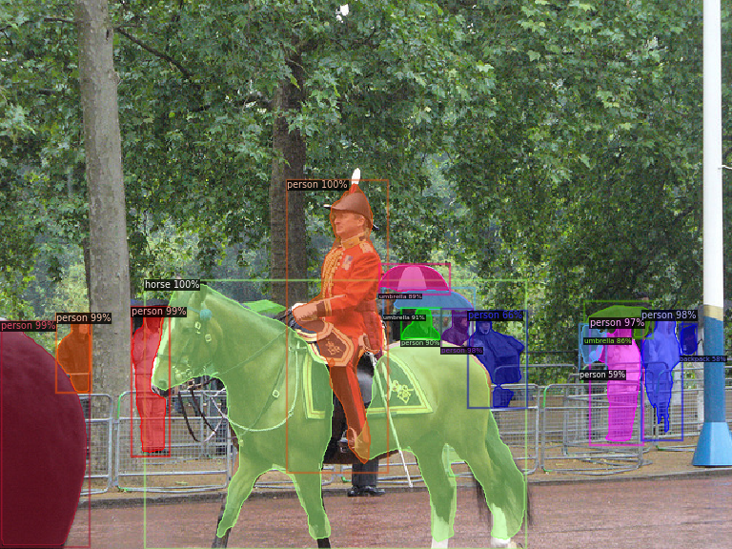

**TFOD with mask RCNN**

The TensorFlow Object Detection API is an open source framework built on top of TensorFlow that makes it easy to construct, train and deploy object detection models.

* Ran both pre-trained and custom dataset(balloon data) model
* Total step=300
* Total loss= 0.1571

**Comparison**

* For pre-trained model, Detectron2 is giving better accuracy than TFOD. Detectron2 predicts human as 100% human but TFOD predicts human as 88% human for same image.
* For custom trained model, TFOD provides lesser total loss than Detectron2 i.e. 0.1571 and 0.3452 for same number of steps and same dataset.
* Overall training of Detectron2 is less complex than TFOD due to the various built in modeules.